**A**

**Project Report**

**On**

**“ACCIDENTAL SWITCH ON/OFF PROTECTION USING DELAY “**

**Prepared By:**

KUSHANG DARBAR (18EC017)

**Under the guidance of:**

Prof. Vishal Tank and Prof. Riki Patel

**Submitted to**

Charotar University of Science & Technology for Partial Fulfilment of the Requirements for the Degree of Bachelors of Technology in Electronics & Communication Engineering

EC 244 – Mini Project-I of 3rd Semester of B.Tech

**Submitted at:**

**DEPARTMENT OF ELECTRONICS & COMMUNICATION ENGINEERING**

**Faculty of Technology & Engineering, CHARUSAT**

**ChanduBhai S. Patel Institute of Technology**

**at Changa, Dist. Anand – 388421**

**November 2019**



**CERTIFICATE**

This is to certify that the report entitled **“ACCIDENTAL SWITCH ON/OFF PROTECTION USING DELAY”** is a bonafide work carried out by Kushang Darbar under the guidance and supervision of **Prof. Vishal Tank** & **Prof. Riki Patel** for the subject **Mini Project-I (EC244)** of 3rd Semester of Bachelor of Technology in Electronics & Communication at Faculty of Technology & Engineering (C.S.P.I.T.) – CHARUSAT, Gujarat.

To the best of my knowledge and belief, this work embodies the work of candidate himself, has duly been completed, and fulfils the requirement of the ordinance relating to the Subject specified for 3rd semester of the University and is up to the standard in respect of content, presentation and language for being referred to the examiner.

Under the supervision of,

Prof. Vishal Tank

Assistant Professor,

Department of Electronics & Communication,

C.S.P.I.T., CHARUSAT - Changa

Prof. Riki Patel

Assistant Professor

Department of Electronics & Communication,

C.S.P.I.T., CHARUSAT - Changa.

Dr Trushit K. Upadhyaya

Head of Department,

Department of Electronics & Communication

C.S.P.I.T., CHARUSAT- Changa, Gujarat**.**

**Chandubhai S Patel Institute of Technology (C.S.P.I.T.)**

**Faculty of Technology & Engineering, CHARUSAT**

At: Changa, Ta. Petlad, Dist. Anand, Gujarat - 388421

**ABSTRACT:**

The project is Accidental switch on/off protection using delay using NE555 timer and a decade counter CD4017B. The timer IC generates the clock pulse through capacitor used respectively.the decade counter, through the output pin of timer IC connected to the clock pin of decade counter, countes the pulse.Accordingly the delay is obtained and the visual feedback given at decade counter is for reference of the user whether the circuit is turned on/off.The purpose of the project is to protect the appliance of the user from accidental switch on/off and the sudden voltage difference created due to that.



**Acknowledgement:**

I take this opportunity to express my profound gratitude and deep regards to my guide Prof. Vishal Tank & Prof. Riki Patel and coordinator of Electronics and Communication department of CSPIT, Dr Trushit Upadhyaya, for their exemplary guidance, monitoring and constant encouragement throughout the course of this project. The blessing, help and guidance given by them time to time shall carry me a long way in the journey of life on which I am about to embark.

I also take this opportunity to express a deep sense of gratitude to Mentor Vishal Tank for his cordial support, valuable information and guidance, which helped me in completing this task through various stages.

Kushang Milind Darbar

ID - 18EC017

CSPIT, CHARUSAT



**TABLE OF CONTENT**

* Abstract..............................................................................................i
* Acknowledgment..............................................................................ii
* List of Figures..................................................................................iv
* Abbrevations.....................................................................................v

**CHAPTER 1: Introduction to Project...............................................1**

1.1: Problem.................................................................................1

1.2: Solution.................................................................................1

**CHAPTER 2: Project Description....................................................2**

2.1: Block Diagram......................................................................2

2.2: Circuit Diagram....................................................................3

**CHAPTER 3: Components and Its Details......................................4**

3.1: List of Components..............................................................4

3.2: Details of Components.........................................................5

**CHAPTER 4: Implementation..........................................................8**

4.1:Hardware Implementation.....................................................8

4.2: PCB Design in Software……………………....................9

**CHAPTER 5: Applications…………………................................12**

5.1: Application.........................................................................12

**Conclusion......................................................................................13**

**References......................................................................................14**

**Datasheet of Components.............................................................15**

**LIST OF FIGURES**

|  |  |  |
| --- | --- | --- |
| **Figure number** | **Figure name** | **Page number** |
| 1 | Block diagram | 2 |
| 2 | Circuit diagram | 3 |
| 3 | Breadboard | 5 |
| 4 | General purpose board | 5 |
| 5 | NE555 | 6 |
| 6 | NE555 Pin diagram | 6 |
| 7 | CD4017B | 6 |
| 8 | CD4017B Pin diagram | 6 |
| 9 | Transistor(BC547) | 7 |
| 10 | Diode(1N4007) | 7 |
| 11 | LED | 7 |
| 12 | Relay | 7 |
| 13 | Breadboard circuit | 9 |
| 14 | General purpose PCB circuit | 9 |
| 15 | Proteus software circuit | 10 |
| 16 | ARES PCB design | 10 |
| 17 | 3-D view of PCB | 11 |



**ABBREVATIONS:**

* IC - Integrated Circuit
* PCB - Printed Circuit Board
* DC - Direct current



**CHAPTER 1: INTRODUCTION TO PROJECT**

* This project “Accidental switch on/off protection using delay” is designed using two different ICs and the other components like transistors, LEDs, relay, resistors, etc.
* In this design, delay is produced and the visual feedback given through LEDs, using the two ICs and other components.
* Thus, the user gets notified that the circuit is switched on or off.

**1.1: PROBLEM**

The problems faced by the user using appliance are:

* Many of the times when the user uses the appliance, it may happen that the switch of the appliance is pressed by mistake, so to avoid any internal damage to the appliance this design is used.
* The accidental pressing of the on/off switch due to human error may cause the failure of the system it is connected to, or cause unnecessary delay to a part of the parent circuit.
* This could, in turn, cost money and time to reset/reboot the system.

**1.2: SOLUTION**

The solution to the problems faced:

* The circuit presented in this requires you to keep the on/off switch pressed for a certain duration to make sure that the action is actually intended and not accidental.

**1**

**CHAPTER 2: PROJECTION DESCRIPTION**

**2.1: BLOCK DIAGRAM**

NE555 timer in astable multivibrator mode

Figure 1:Block diagram

User gets the desired output

**2**

Gives visual feedback to the user

Timer IC gives clock pulse as output

Relay energises/de-energises respectively

CD4017B takes the output from timer IC

**2.2: CIRCUIT DIAGRAM**

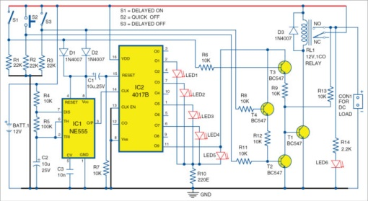

Figure 2: Circuit diagram

**WORKING**

* The circuit employs 555 timer IC, wired in astable-multivibrator mode, which serves as the clock source.
* Decade counter IC CD4017 provides visual feedback on how long you should keep pressing the on/off switch to achieve the desired action.
* 12V DC load can be connected to relay output, which is controlled through switches S1 through S3.
* Delay timing of IC1 is decided by timing components, namely, resistors R4 and R5, and capacitor C2.
* LED1 through LED5 provide visual delay indication.
* On closing delay-on switch S1, transistor T3 conducts.
* IC1 starts oscillating, IC2 starts counting and LED1 through LED5 glow one after another and when IC2 counts to Q9 (at pin 11), its output turns on T1, relay RL1 energises.

**3**

**CHAPTER 3: COMPONENTS AND ITS DETAILS**

**3.1: COMPONENTS LIST**

|  |  |  |  |
| --- | --- | --- | --- |
| **Sr. No.** | **Component Name** | **Quantity** | **Specification** |
| 1 | Bread board | 3 | - |
| 2 | General purpose board | 1 | - |
| 3 | NE555 timer (IC1) | 1 | - |
| 4 | Decade counter CD4017B (IC2) | 1 | - |
| 5 | LED | 6 | Maximum voltage 2v |
| 6 | npn transistors BC547 | 4 | - |
| 7 | Battery | 1 | 12 V |
| 8 | 22k Ω | 3 | Tolerance 5% |
| 9 | 10k Ω | 7 | Tolerance 5% |
| 10 | 2.2k Ω | 1 | Tolerance 5% |
| 11 | 100k Ω | 1 | Tolerance 5% |
| 12 | 220E Ω | 1 | Tolerance 5% |
| 13 | Pushbutton switch | 2 | - |
| 14 | Toggle switch | 1 | - |
| 15 | Diode 1N4007 | 3 | - |
| 16 | Relay | 1 | 12 V |
| 17 | Wires | - | - |
| 18 | Capacitor | 2  1 | 10uF,25 V  10n |

**4**

**3.2: DETAILS OF COMPONENTS**

* **Breadboard**
* A breadboard is a solderless device for temporary prototype with electronics and test circuit designs. Most electronic components in electronic circuits can be interconnected by inserting their leads or terminals into the holes and then making connections through wires where appropriate. The breadboard has strips of metal underneath the board and connect the holes on the top of the board. The metal strips are laid out as shown below. Note that the top and bottom rows of holes are connected horizontally and split in the middle while the remaining holes are connected vertically.

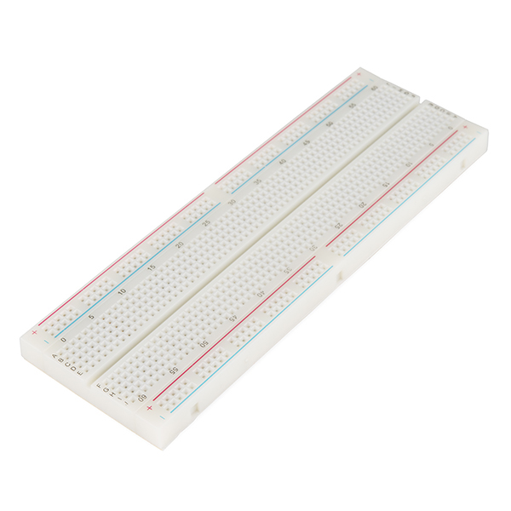

Figure 3: Breadboard

* **General purpose board**
* As its name suggests, **general purpose PCB's** are widely used to embed circuits randomly for running of hardware. Its layer is coated with copper and allows proper soldering without any short circuit. **General purpose board**, connections are not built so connections are to be created.

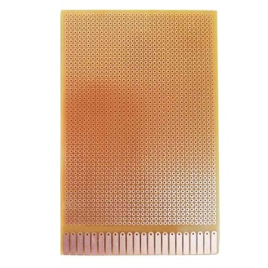

**Figure 4: General purpose board**

**5**

* **NE555 timer(IC1)**

The 555 timer IC is an integrated circuit(chip) used in a variety of timer, pulse generation, and oscillator applications. The 555 can be used to provide time delays, as an oscillator, and as a flip-flop element.The standard 555 package includes 25 transistors, 2 diodes and 15 resistors on a silicon chip installed in an 8-pin dual in-line package (DIP-8).

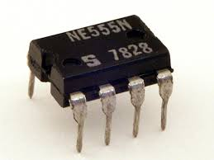

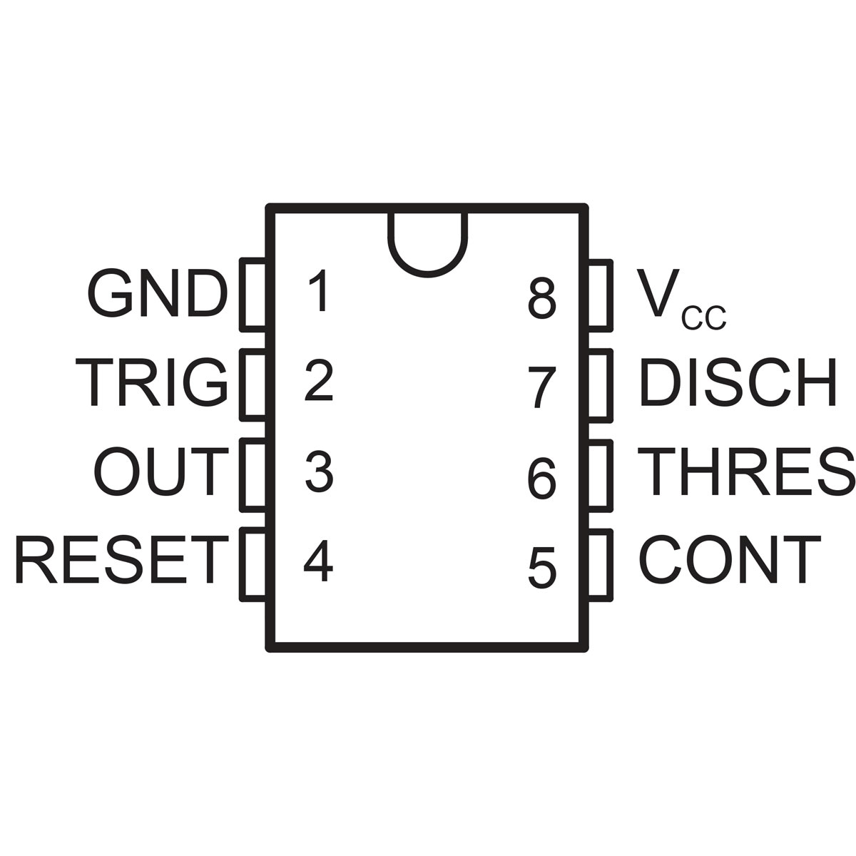

Figure 5:NE555 Figure 6:NE555 Pin diagram

* **CD4017B(IC2)**

CD4017B are 4-stage Johnson counters having 8 decoded outputs. Inputs include a CLOCK, a RESET, and a CLOCK INHIBIT signal. Schmitt trigger action in the CLOCK input circuit provides pulse shaping that allows unlimited clock input pulse rise and fall times.

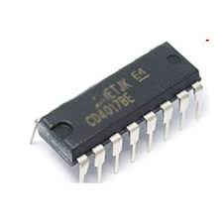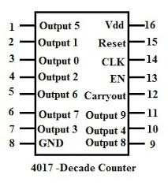

**Figure 7:** **CD4017B Figure 8:CD4017B Pin diagram**

**6**

* **Transistor BC547**

**BC547** is an NPN bi-polar junction **transistor**.

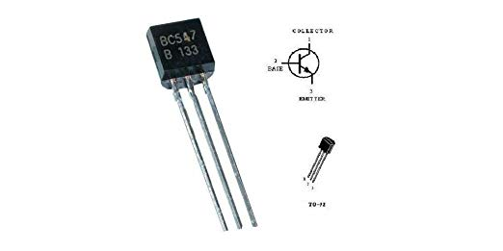

**Figure 9:Transistor(BC547)**

* **Diode(1N4007)**

**1N4007** is a PN junction rectifier **diode**. These types of **diodes** allow only the flow of electrical current in one direction only. So, it can be **used** for the conversion of AC power to DC.

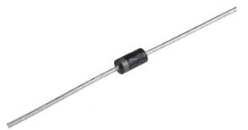

**Figure 10:Diode(1N4007)**

* **LED**

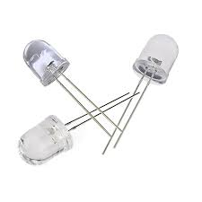

**Figure 11:LED**

* **Relay**

**Relays** are switches that open and close circuits electromechanically or electronically. **Relays** control one electrical circuit by opening and closing contacts in another circuit.

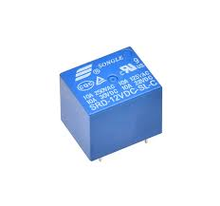

**Figure 12:Relay**

**7**

**CHAPTER 4: IMPLEMENTATION**

**4.1(a): Hardware Implementation on Breadboard**

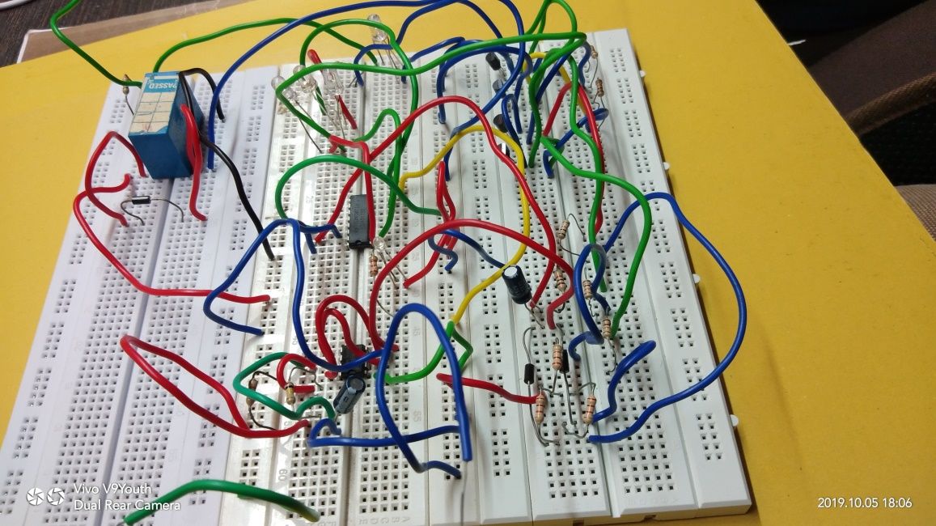

**Figure 13:Breadboard circuit**

**(b) Hardware Implementation on GENERAL**

**PURPOSE PCB**

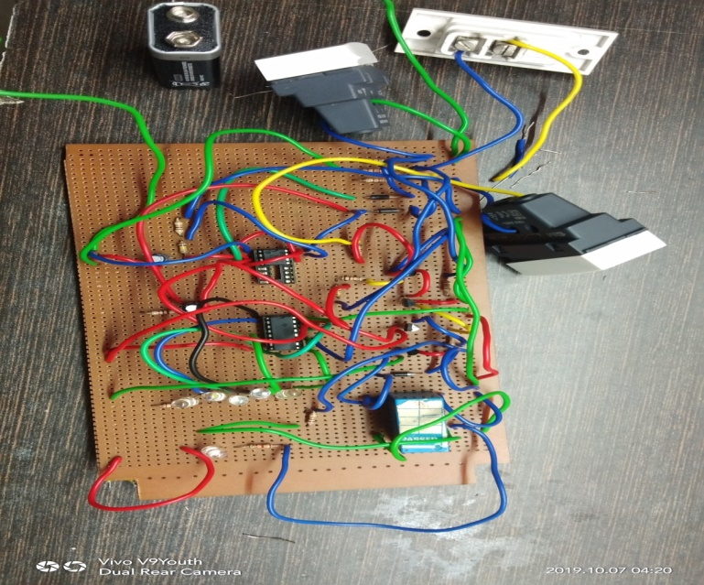

Figure 14:General Purpose PCB circuit

**8**

**4.2(a):CIRCUIT IMPLEMENTATION ON PROTEUS SOFTWARE**

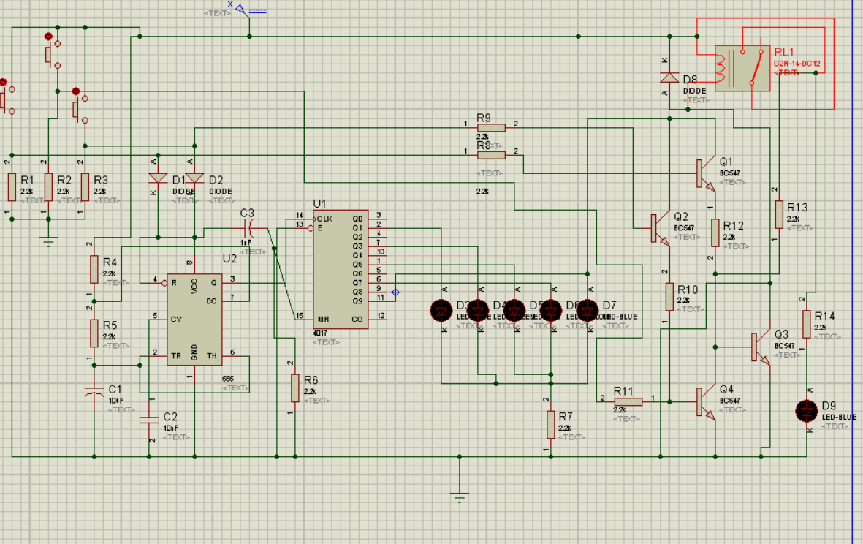

Figure 15:Proteus Software circuit

**(b)ARES PCB DESIGN**

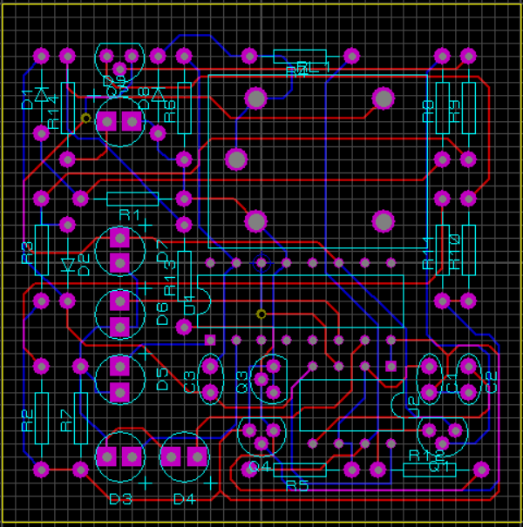

Figure 16:ARES PCB design

**9**

**(c) 3 – D VIEW OF PCB**

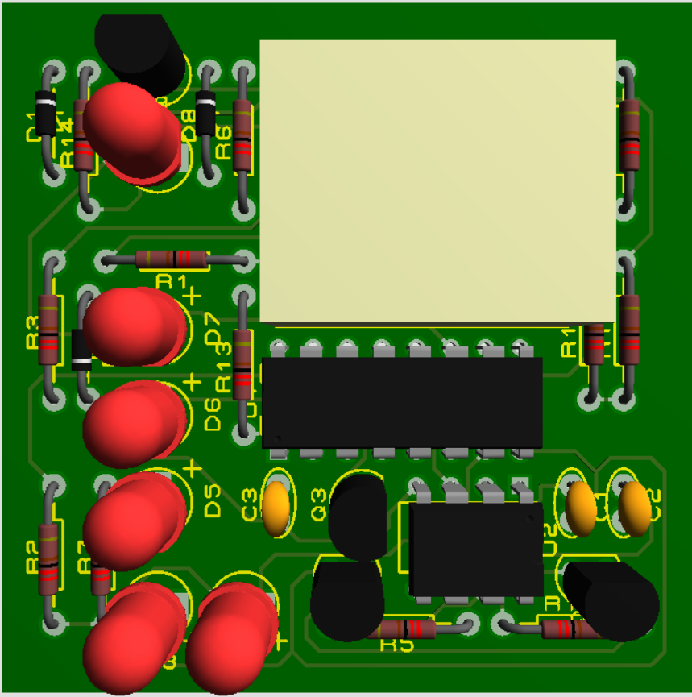

Figure 17:3-D view of PCB

**10**

**CHAPTER 5: APPLICATIONS**

**5.1: APPLICATIONS**

* Used to protect the home appliances from voltage fluctuations by connecting a power guard in the circuit.
* Even in the industries and other commercial purpose, this is used.
* In the industries and commercial purposes,the supply given in the circuit is AC and it may contain the changes in the circuit respectively.
* For example, the circuit will consist of the Triac. **Time delay Circuit using Triac and 555 Timer** is very useful when we want to activate or switch on, appliances or devices that works on alternating current (AC), after a preset time.
* The timer triggers a TRIAC that works as a solid state relay and can control a load of up to 4 amps, when connected to 110 VAC.
* The output of the timer 555 (pin 3) which is connected to the gate (G) of the TRIAC through the resistor, powers on the load.
* The 555 timer and its associated elements operate with 10 DC volts. This voltage is obtained using a transformerless voltage source implemented with a zener diode, a resistor, an electrolytic capacitor and a rectifier diode.
* The main application of the project is, it is used to protect the electronic device from being damaged due to unintentional switch on/off.

**11**

CONCLUSION:

* 1. First, implementing the circuit in the software is important. Here the software used is PROTEUS and ARES.
  2. Drawing the circuit in the Schematic and then Simulating, implementing the circuit on the breadboard gives the idea that whether the connections are properly connected and desired output is getting or not.
  3. When the PROTEUS circuit is working properly, then implement the ARES PCB design.
  4. Some packages were not available in ARES, so I learnt to download them.
  5. The 3-D view of circuit gives basic idea of implementing circuit on Breadboard and General-Purpose PCB.
  6. After checking the circuit connections on the breadboard, implemented the circuit on general purpose board and learnt to solder the components used in the circuit.
  7. Learnt, how to read datasheet of ICs, Transistors, etc.

**12**

**REFERENCES:**

1. <https://electronicsforu.com/electronics-projects/accidental-switch-on-switch-off-protection-using-delay>
2. <https://electronicsforu.com/resources/learn-electronics/555-timer-working-specifications>
3. <https://www.elprocus.com/ic-4017-pin-configuration-application/>
4. Electronics for You – vol. 1

**13**

**DATASHEETS OF COMPONENTS**

* **Datasheet for NE555 IC**

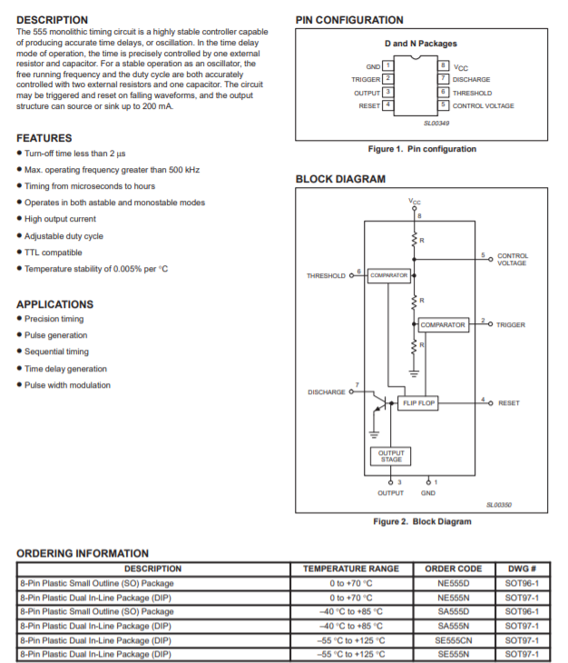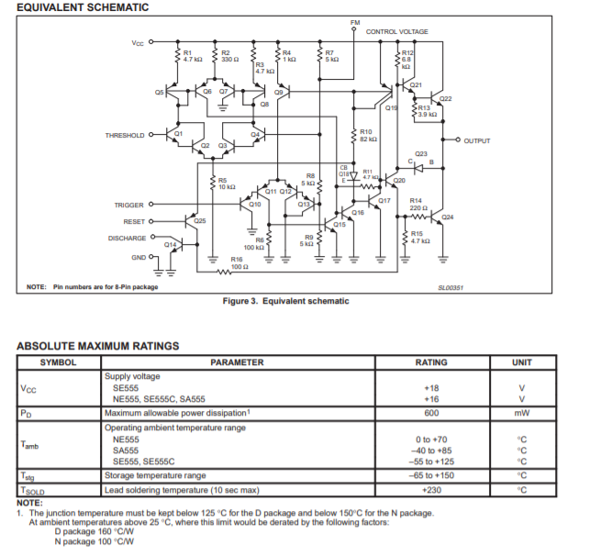

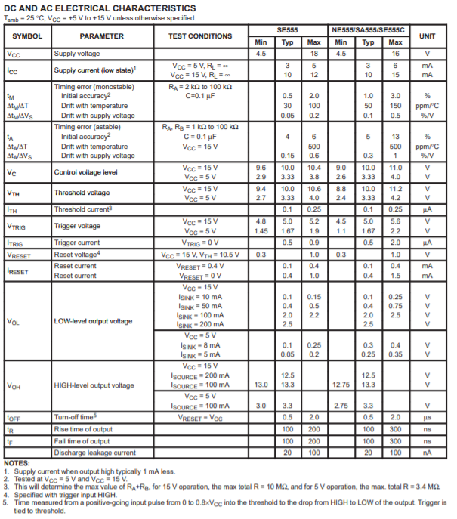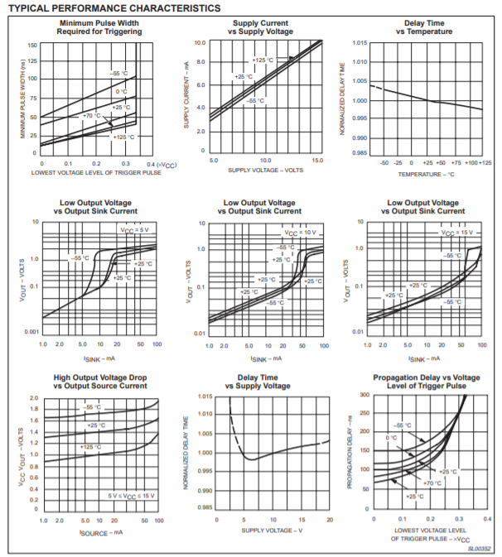

**14**

* **Datasheet for CD4017B**

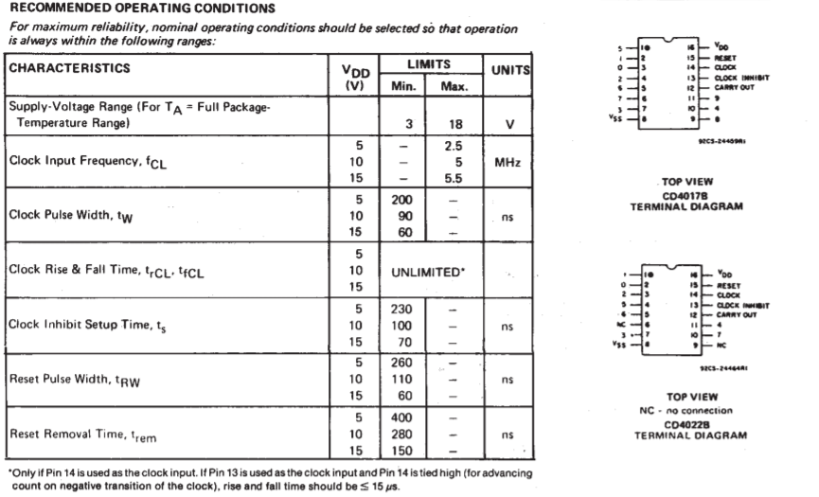

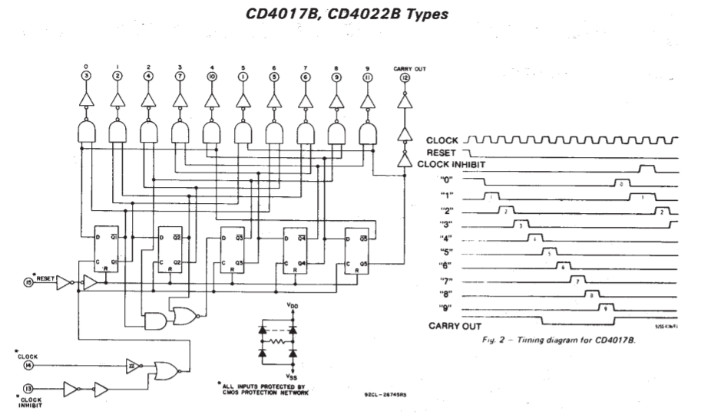

**15**

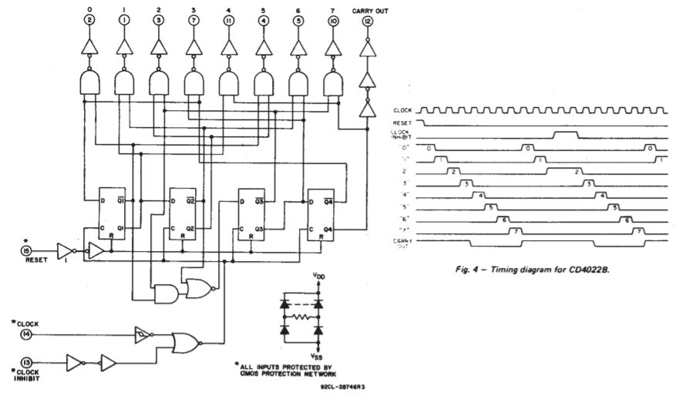

**16**

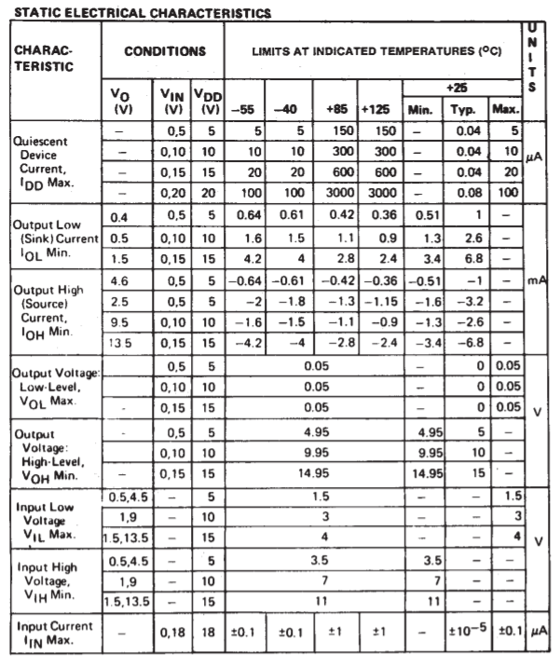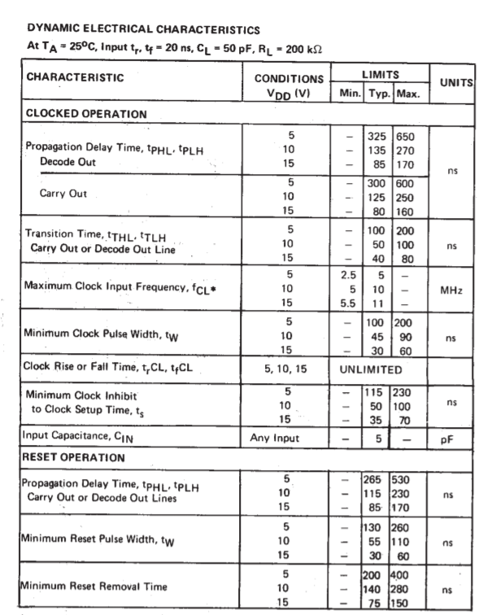

**17**

**18**

* **Datasheet for Transistor BC547**

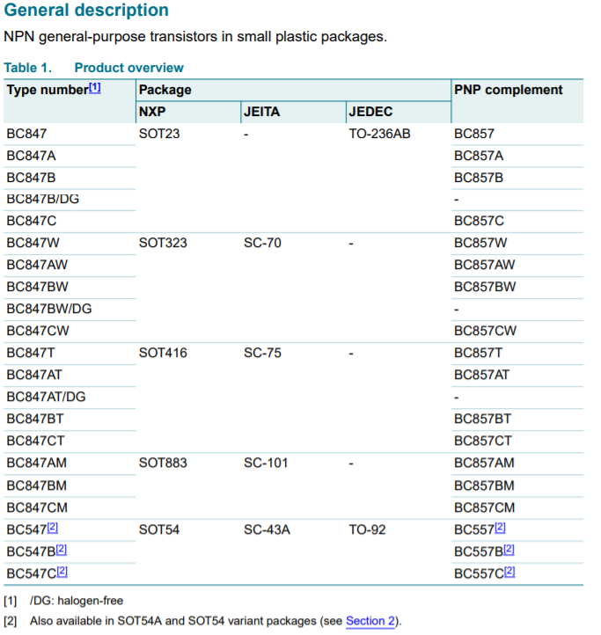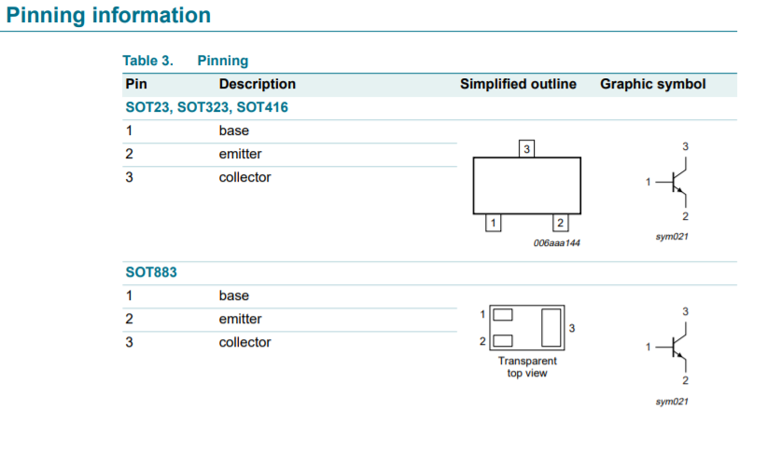

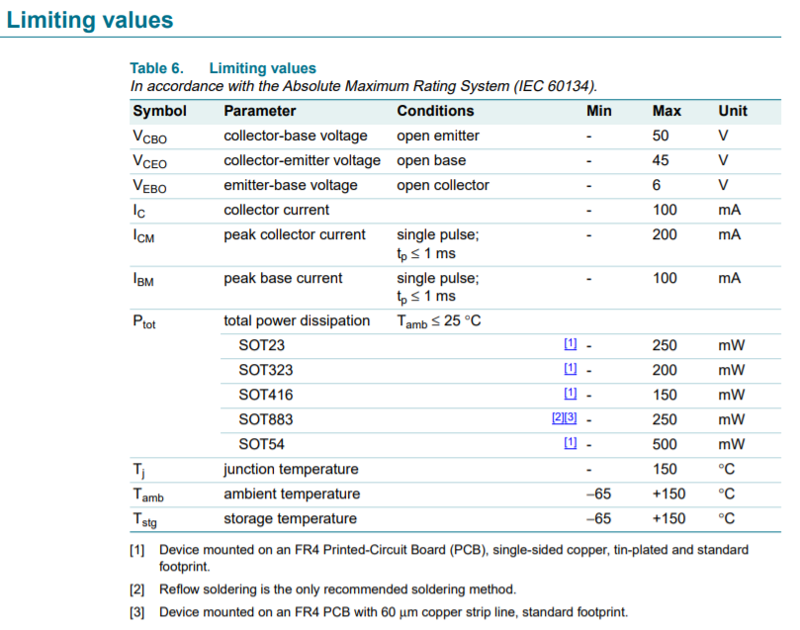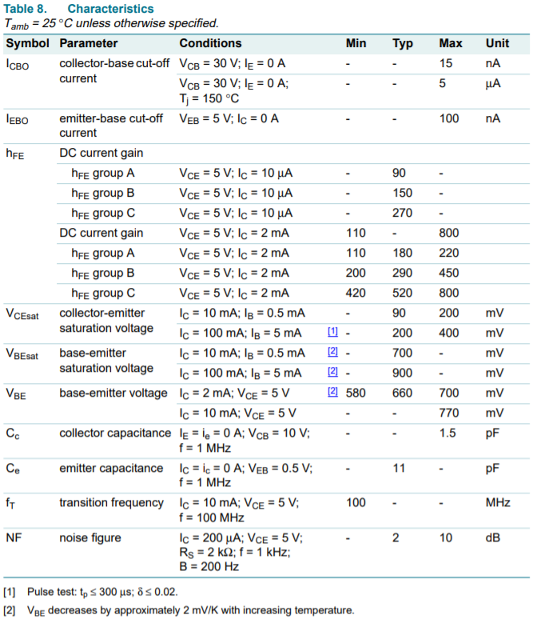

**19**

* **Datasheet for Diode 1N4007**

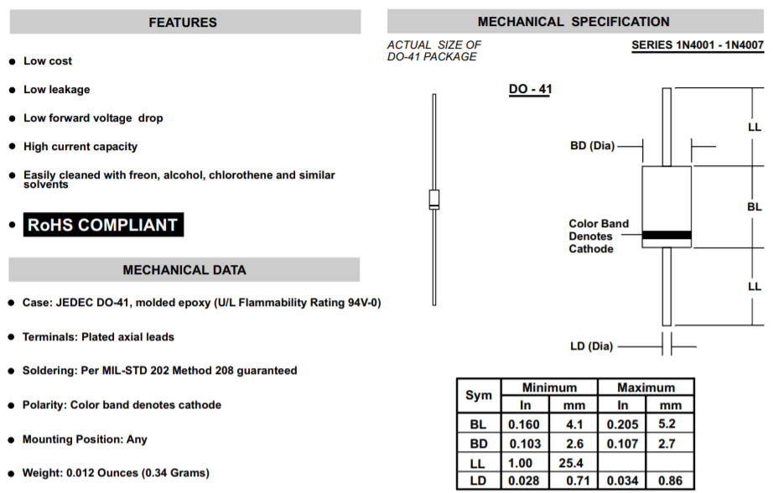

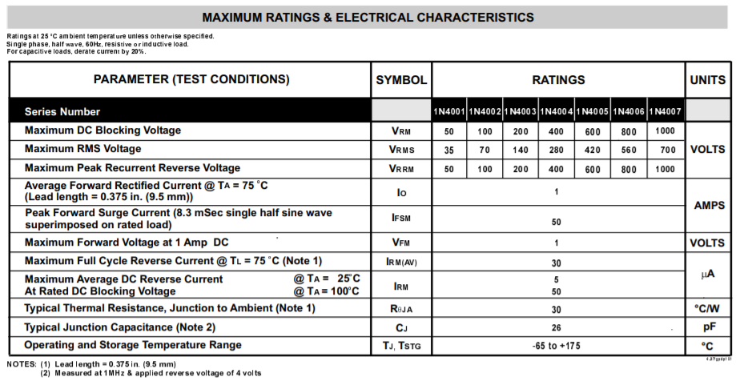

**20**